CashTech Site Review Checklist
for

Tidel Series D3 XL w/o Storage Vault

(Installation)

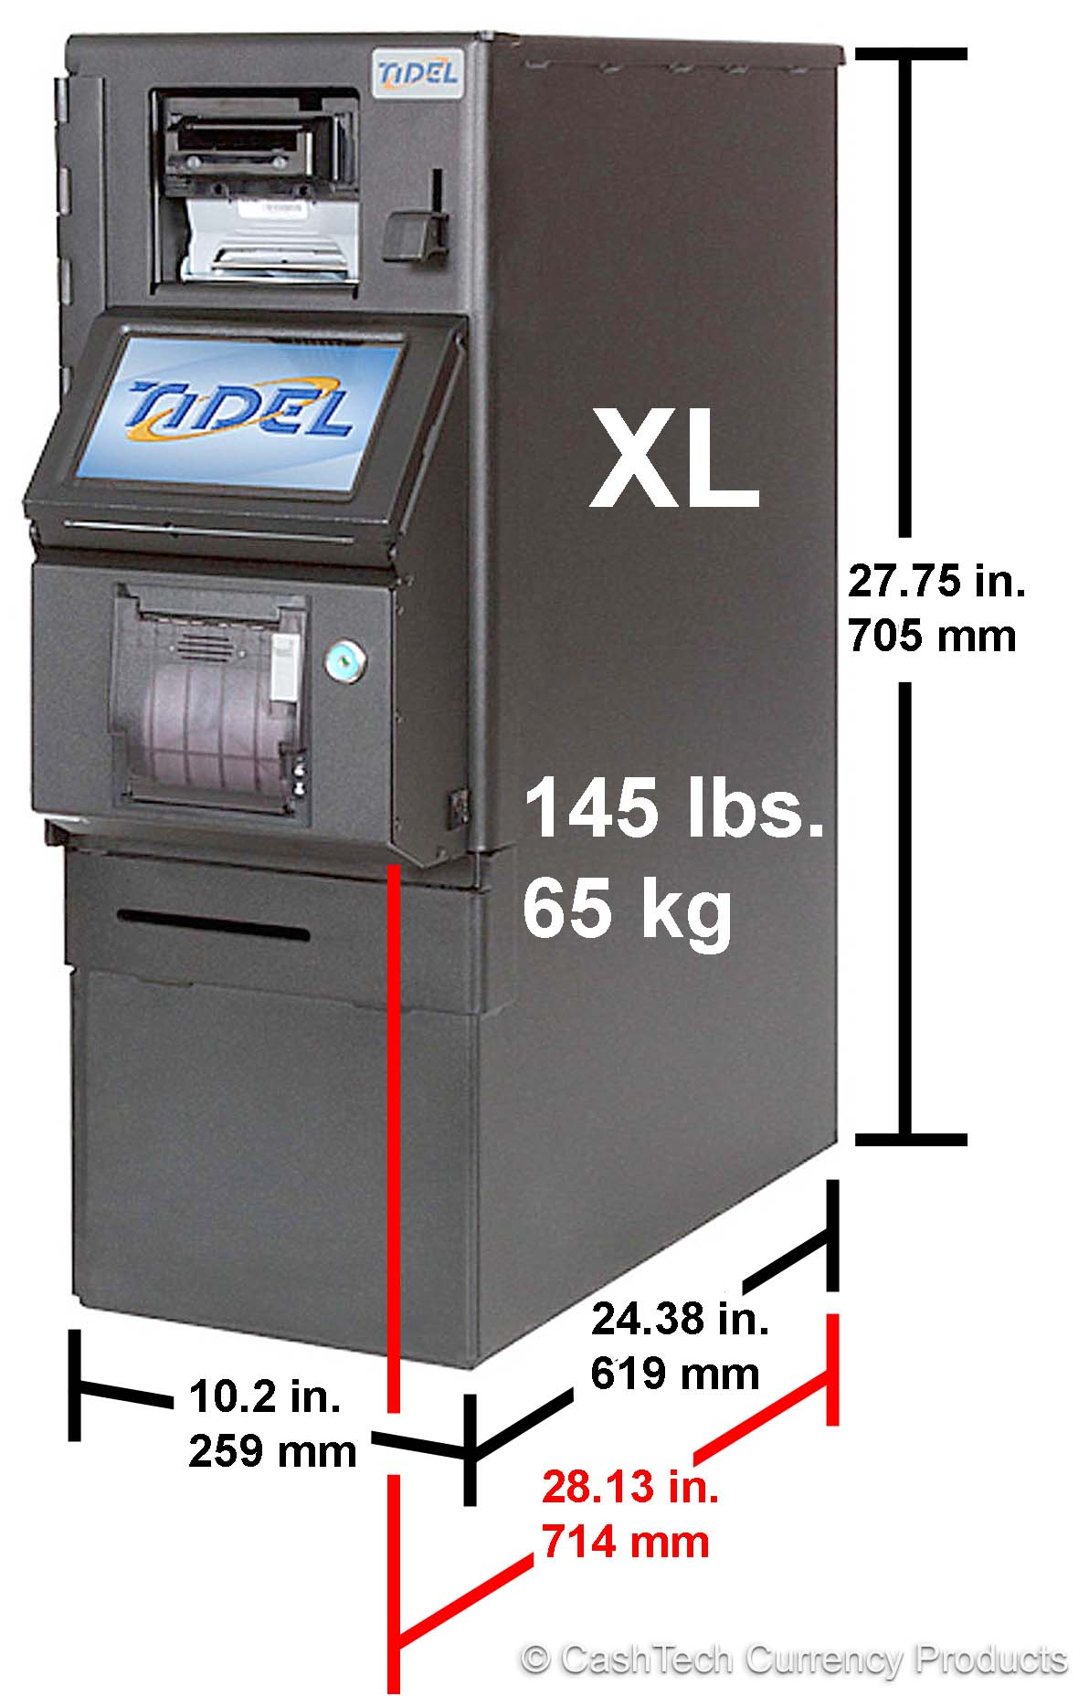

CashTech Site Review Checklist
(To be completed by Service technician)

Contact Info
- Company Name:
- Contact Name:
- Address:
- Contact Phone #:
- Contact Email:

System Configuration
Module list: Tidel D3 XL without storage vault

Safe Weight & Dimensions

Note Safe
65 kg / 145lbs. | Total Weight
259 mm / 10.2 in. | Total Width
714 mm / 28.13 in. | Total Depth
705 mm / 27.75 in. | Total Height

Anchors & bolts supplied with system.
3” x 3/8” wedge anchors
1 ¼” flat washers
2 ½” flat washers

Days and Hours of Operations

Days | Open | Close
Monday
Tuesday
Wednesday
Thursday
Friday
Saturday
Sunday

CashTech Site Review Checklist
(To be completed by Service technician)

Delivery instructions to ask client

- How many days prior to installation can the safe be delivered?
- Is there space to store the safe after delivery until it is installed (Y/N)? Where?
- Delivery Hours?
- Delivery Location, front (Y/N)?, back (Y/N)? or other (Y/N)?
- What floor number is the safe to be stored on?
Steps (Y/N)?
Stairs (Y/N)?
Ramps (Y/N)?
- Is there an elevator (Y/N)? Maximum capacity? Door size? Elevator dimensions?
- Is there a loading dock (Y/N)? If not, will the delivery truck need a lift gate? (Y/N) (Usually Yes if no dock)
- Describe the flooring.
Any weight restrictions to moving the safe (Y/N)?
What method can be used to move the safe:
Pallet jack (Y/N)?
Dolly (Y/N)?
Hand truck (Y/N)?
- What is the minimum door width for delivery?
- Describe the equipment path from the entry point of the building to its final stored location.
- Attach photos of the delivery path.

CashTech Site Review Checklist
(To be completed by Service technician)

Installation location

- How far is the safe stored from the installation location?
- Is the safe stored on a different floor number?
Steps (Y/N)?
Stairs (Y/N)?
Ramps (Y/N)?
- What method can be used to move the safe to the installation location:
Sliding by hand (Y/N)?
Pallet jack (Y/N)?
Dolly (Y/N)?
Hand truck (Y/N)?
- What is the smallest door size to get the safe from its stored location to the install location?
- What is the room size (length, width and height)?
- Will the safe be installed 6 feet away from a water source (Y/N)?
- Will the safe be installed near any heaters or radiators (Y/N)?
- Is there sufficient space for the safe?
Minimum Required Space:
Height: 30 inches.
Width: 16 inches (allow door to open)
Length: 30 inches
- What is the Floor type:
Wood (Y/N)?
Ceramic Tile (Y/N)?
Linoleum (Y/N)?
Carpet (Y/N)?
Other (Y/N)?
- What is the sub floor type:
Wood structure (Y/N)?
Concrete (Y/N)?
- Are there any restrictions to drilling into the floor (Y/N/Unknown)?
Is a Floor Scan required (Y/N/Unknown)?
(If personnel on site do not know, state, Unknown)
- If there are restrictions to drilling into the flooring, what are they?
- Any imbedded obstacles in the floor:
Power Line (Y/N)?
Water pipe (Y/N)?
Sewer pipe (Y/N)?
Heated floors (Y/N)?
- Are there time restrictions for drilling the floor:
Done before store opens (Y/N)?
Can drilling be done during regular business hours (Y/N)?
- Are there at least 2x power outlets available within 6 feet (Y/N)?
- Is there a nearby network jack to an Ethernet connection if required (Y/N)? How far?
- Provide Speedtest at safe installation location.  Must turn off 5G and use the Bell network. | Download = Mbps  Upload = Mbps
- Is there any existing safe that will interfere will the Tidel safe’s operation (Y/N)?
- Is there any existing safe that must be removed to make room for the Tidel safe (Y/N)?
- Describe the installation area and add the necessary photos.

Site Survey Photos

Insert site survey photos below.

